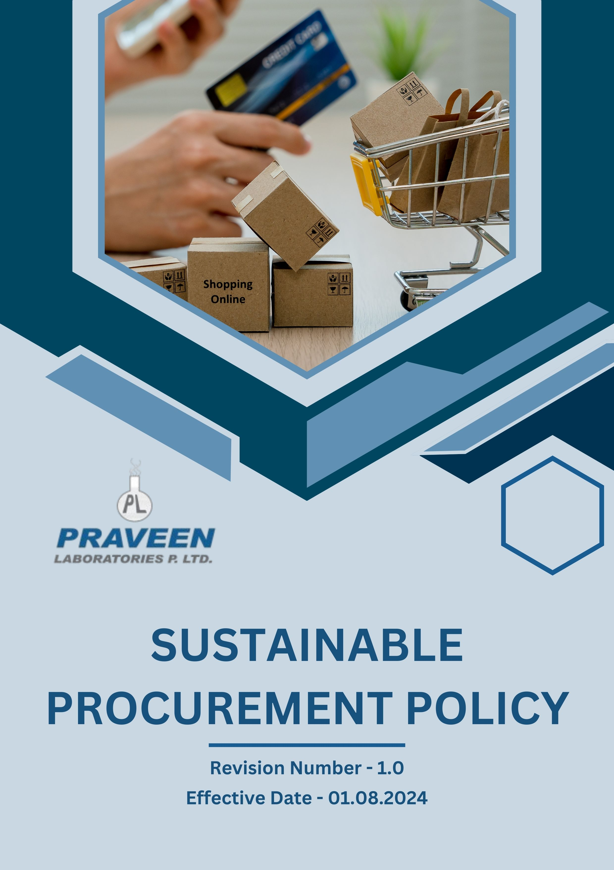

Table Of Contents

1. Overview 3
2. The PRAVEEN LABORATORIES PVT. LTD. Strategy 3
3. Applicability 3
4. Primary Objective 3
5. Journey to Sustainability: A PRAVEEN LABORATORIES PVT. LTD. Commitment: 4
6. General Sustainable Procurement Targets: 5
7. Responsibility of this Policy: 6
8. Governance 7
9. Reporting Section: 7
10. Covered SDGs: 8
11. Review Mechanism: 8
12. Employee Acknowledgement Form: Sustainable Procurement 9

Overview
To achieve our goals and uphold ethical conduct, it is essential that our suppliers align with our values and vision while enhancing sustainability standards within our supply chain. We recognize that the long-term sustainable development of our suppliers is vital to our mutual success, and we appreciate our partnerships with those who share our commitment to responsible business practices. In support of this commitment, we have established a Sustainable Procurement Policy, which reflects our core values and applies to all our suppliers. We expect our suppliers to operate in accordance with the principles outlined in this Policy and to comply with all relevant laws and regulations.

The PRAVEEN LABORATORIES PVT. LTD. Strategy
At Praveen Laboratories Pvt. Ltd., we integrate sustainability into our procurement practices by fostering strong partnerships with suppliers who share our commitment to ethical and environmental standards. We work closely with suppliers to ensure alignment with sustainability goals and provide support for continuous improvement. Additionally, we actively seek sustainable raw materials, packaging solutions, and manufacturing processes to reduce our environmental footprint.

We set annual goals, develop necessary capabilities, and commit appropriate resources to achieve this policy and align Praveen Laboratories Pvt. Ltd. supply chain with this policy.

Applicability
This policy applies to all procurement activities, including raw materials, packaging, and services, and covers all suppliers, contractors, and business partners.
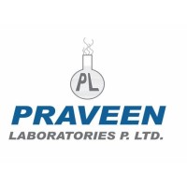 | Praveen Laboratories Pvt. Ltd.
 | Office Address: 720, Golden Point, Falsawadi, Ring Road, Surat-395003, Gujarat, India
 | Factory Address: BlockNo.206, Village: Jolwa, Taluka: Palsana, Dist: Surat‐394305, Gujarat, India
 | http://www.praveenlabs.com/

Primary Objective

- Compliance with Laws and Regulations
All relevant national and international laws and regulations are closely adhered to by PRAVEEN LABORATORIES PVT. LTD. to foster sustainable procurement. We have established key commitment to sustainable procurement practices:

- Environmental Issue
  - Prioritize suppliers that adhere to environmentally responsible practices, including energy efficiency, waste reduction, and pollution control.
  - Require suppliers to comply with environmental regulations and industry best practices.
  - Collaborate with suppliers to improve sustainability performance through joint initiatives and capacity-building programs.
  - Promote the procurement of raw materials and products with lower environmental footprints, such as recycled, biodegradable, or sustainably sourced materials.
  - Minimize packaging waste by encouraging suppliers to use eco-friendly packaging solutions.
  - Encourage suppliers to measure, report, and reduce their CO2, other Greenhouse Gases, SO_{x}, NO_{x}, and Particulate Matter emissions.
  - We expect our suppliers to assess their use of hazardous and toxic material and take necessary steps to reduce it, as much as possible.

- Labor Practices and Human Rights
  - Require all suppliers to comply with labor standards, including those set by the National labor laws.
  - Ensure that employment conditions within the supply chain are free from discrimination, forced labor, child labor, and any form of exploitation.
  - Work with suppliers to maintain safe, hygienic, and working conditions for all employees.
  - Support and prioritize business relationships with suppliers that demonstrate commitments to diversity, equity, and inclusion.
  - Implement a supplier code of conduct that outlines labor rights expectations and ethical procurement guidelines.

Journey to Sustainability: A PRAVEEN LABORATORIES PVT. LTD. Commitment:
Considering calendar year 2022 as the Baseline year for measuring progress and achievements in our sustainability initiatives.

- Environmental Issue:
  - We strive to significantly reduce procurement-related carbon emissions by 10% by 2026, that promote sustainability and environmental responsibility throughout our supply chain.
  - We seek to ensure that at least 15% of our suppliers adopt energy-efficient production processes by the year 2026, fostering partnerships that prioritize eco-friendly practices and contribute to a greener economy.
  - Set a goal to achieve a minimum of 15% procurement of biodegradable and recyclable materials by 2026.
  - Our objective is to significantly reduce Scope 1, 2 & 3 emissions associated with procurement activities by 10% by the year 2026.
  - We are committed to implementing effective strategies that will lead to a reduction in water usage throughout our supply chain, aiming for a substantial decrease of 15% by 2026.
  - Aim for 100% of procurement staff are trained on environment friendly sourcing by 2026.

- Labor Practices and Human Rights:
  - Our objective is to conduct comprehensive supplier audits focusing on labor conditions, aiming for a complete 100% compliance rate by the year 2026.
  - We are committed to ensuring that at least 80% of our key suppliers adopt and implement fair wage policies by 2026. This commitment reflects our dedication to promoting equitable compensation practices that support the well-being of workers throughout our supply chain.
  - We have set an ambitious goal to increase our procurement from diverse suppliers by 20% by the year 2026.
  - We are dedicated to achieve 100% compliance in all supplier contracts by 2026. This commitment underscores our focus on accountability and transparency, ensuring that all contractual agreements are upheld to the highest standards.
  - Aim for 100% of procurement staff are trained on social responsibility, human rights, and ethical sourcing by 2026.

- Quality Management & Controls:
  - Ensure that 100% of our critical suppliers are in full compliance with ISO 9001 quality management standards by the year 2026, thereby enhancing our overall quality assurance processes and fostering stronger partnerships with our suppliers.
  - Conduct comprehensive annual quality audits on all major suppliers to systematically evaluate their adherence to our quality standards and identify areas for improvement.
  - We strive to reduce the incidence of defective or non-compliant procurement materials by an ambitious 25% by the year 2026, achieved through the implementation of stringent quality checks.

General Sustainable Procurement Targets:
  - We aim to guarantee that all suppliers take part in CSR self-assessments and on-site audits by the end of 2026.
  - Our goal is to have the "Supplier Code of Conduct" signed by all of our suppliers by year 2026.
  - Every two to three years, or sooner if necessary due to modifications in governmental legislation, we want to incorporate extra ESG criteria into supplier contracts.
  - We plan to complete yearly ESG performance evaluations for all suppliers by 2026.
  - We will put corrective action plans into place for suppliers who are not in compliance, with the goal of achieving a 90% resolution rate in 12–15 months by 2026.

Responsibility of this Policy:
- Managing Director:
  - Ensure that sustainability risks in the supply chain are identified and mitigated at the highest level.
  - Promote a corporate culture that prioritizes responsible sourcing and ethical procurement.

- Chief Sustainability Officer:
  - Developing and implementing sustainable procurement strategies in line with corporate sustainability objectives.
  - Monitoring supplier compliance with environmental, social, and ethical standards and reporting on procurement sustainability performance to the Board and stakeholders.

- Sustainability Committee:
  - Evaluating the environmental and social impact of procurement practices.
  - Engaging with external stakeholders to promote sustainable sourcing.
  - Setting and monitoring sustainability-related procurement goals and targets.

- Procurement & Supply Chain Department:
  - Communicate sustainability expectations and requirements to suppliers.
  - Identify procurement-related sustainability risks and mitigate them proactively.
  - Encourage suppliers to improve their sustainability performance through training and collaboration.

- Compliance Manager:
  - Conducting audits and assessments of supplier’s sustainability practices.
  - Investigating and addressing non-compliance with the Sustainable Procurement Policy and keeping up to date with emerging sustainability laws and standards and ensuring compliance.

- Employees:
  - Adhere to the Sustainable Procurement Policy in their roles and contribute to a culture of sustainable procurement by collaborating with suppliers and stakeholders responsibly.
  - Report any sustainability or ethical concerns in procurement practices.

Governance
Praveen Laboratories Pvt. Ltd. ensures strong governance in sustainable procurement through leadership oversight and accountability. The Managing Director mitigates sustainability risks, while the Chief Sustainability Officer develops strategies and monitors compliance. The Sustainability Committee evaluates impacts and engages stakeholders. The Procurement & Supply Chain Department ensures supplier adherence, and the Compliance Manager conducts audits. Employees uphold policy standards. Regular audits, stakeholder engagement, and policy updates drive continuous improvement, reinforcing the company’s commitment to ethical sourcing and environmental responsibility.

Reporting Section:
- Annual Public Sustainability Reporting:
  - External reporting is conducted annually to communicate our sustainable procurement performance to stakeholders, including employees, customers, investors, and regulatory bodies.
  - Reports are prepared in accordance with internationally recognized standards such as the United Nations Global Compact (UNGC), Global Reporting Initiative (GRI).

- Supplier Sustainability Compliance Reporting:
  - We require suppliers to submit annual reports detailing their compliance with environmental, social, and ethical procurement requirements, including any corrective actions taken.
  - Audits and third-party sustainability assessments are conducted to verify compliance with our Supplier Code of Conduct and Sustainable Procurement Policy.

- Stakeholder Engagement:
  - We actively engage with employees, suppliers, and other stakeholders to gather feedback, address concerns, and ensure transparency in our sustainable procurement practices.
  - Regular supplier assessments, training sessions, and stakeholder surveys help measure the effectiveness of our sustainable procurement initiatives and drive continuous improvement.

- Grievance Mechanisms:
  - A formal grievance mechanism is in place to allow employees, suppliers, and external stakeholders to report sustainability violations or unethical procurement practices confidentially and without fear of retaliation.
  - All reports are reviewed by the Compliance Manager and Procurement & Sustainability teams and addressed according to established procedures.

Covered SDGs:


Review Mechanism:

  - The Chief Sustainability Officer reviews this policy annually to ensure alignment with evolving regulations, industry best practices, and stakeholder expectations.
  - Company can also change or review policy if any necessary changes is required.
  - Updates to the policy are communicated internally and externally, and relevant training is provided to procurement teams and suppliers to ensure awareness and compliance with sustainable procurement standards.

(Signature)
Approved By: General Manager
Next Review Date: 31-07-2025

Employee Acknowledgement Form: Sustainable Procurement Policy

I acknowledge that I have received, read, and understood PRAVEEN LABORATORIES PVT. LTD. Sustainable Procurement Policy. I am aware of the company's commitment to upholding sustainable practices, promoting a diverse and inclusive supply chain, and ensuring the protection of human rights across all operations and sourcing activities.
I understand my role in supporting this policy, including complying with all applicable laws and regulations, respecting human rights, and fostering a sustainable and inclusive work environment. I agree to adhere to sustainable practices in my daily work, report any sustainability concerns, and contribute ideas for continuous improvement.
By signing below, I confirm my commitment to upholding PRAVEEN LABORATORIES PVT. LTD. Sustainable Procurement Policy and supporting the company’s efforts in maintaining sustainable practices.

Employee Name: ______________________
Date: _______________
Employee Signature: ____________________

